Assign Roles to New Users Documentation
For safety reasons, only users with the role “Youth Council Member” are able to view the location and timing information of volunteer events. Listed below are the steps to register a user with the role.

- Navigate to the Wix dashboard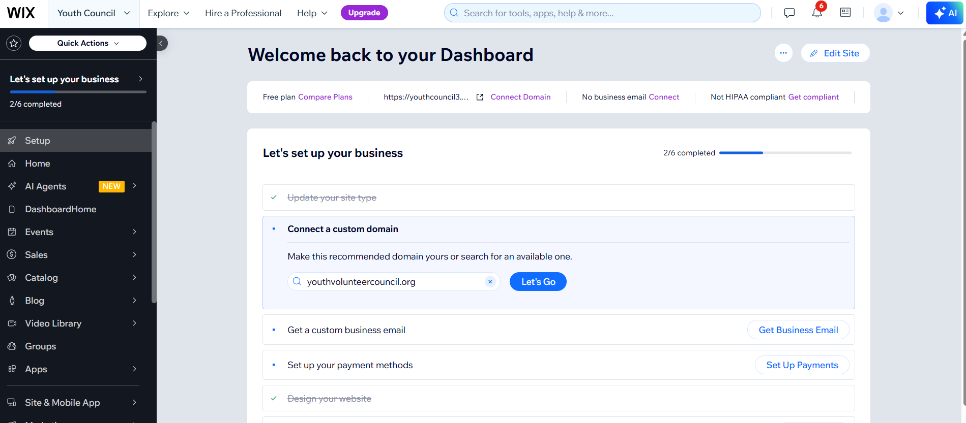
- Scroll until you see “Customers and Leads”, then click on “Contacts”
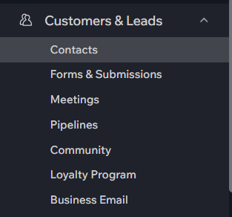
- From here, you will see a list of accounts registered on the site. Next, click on the three dots next to the user’s name.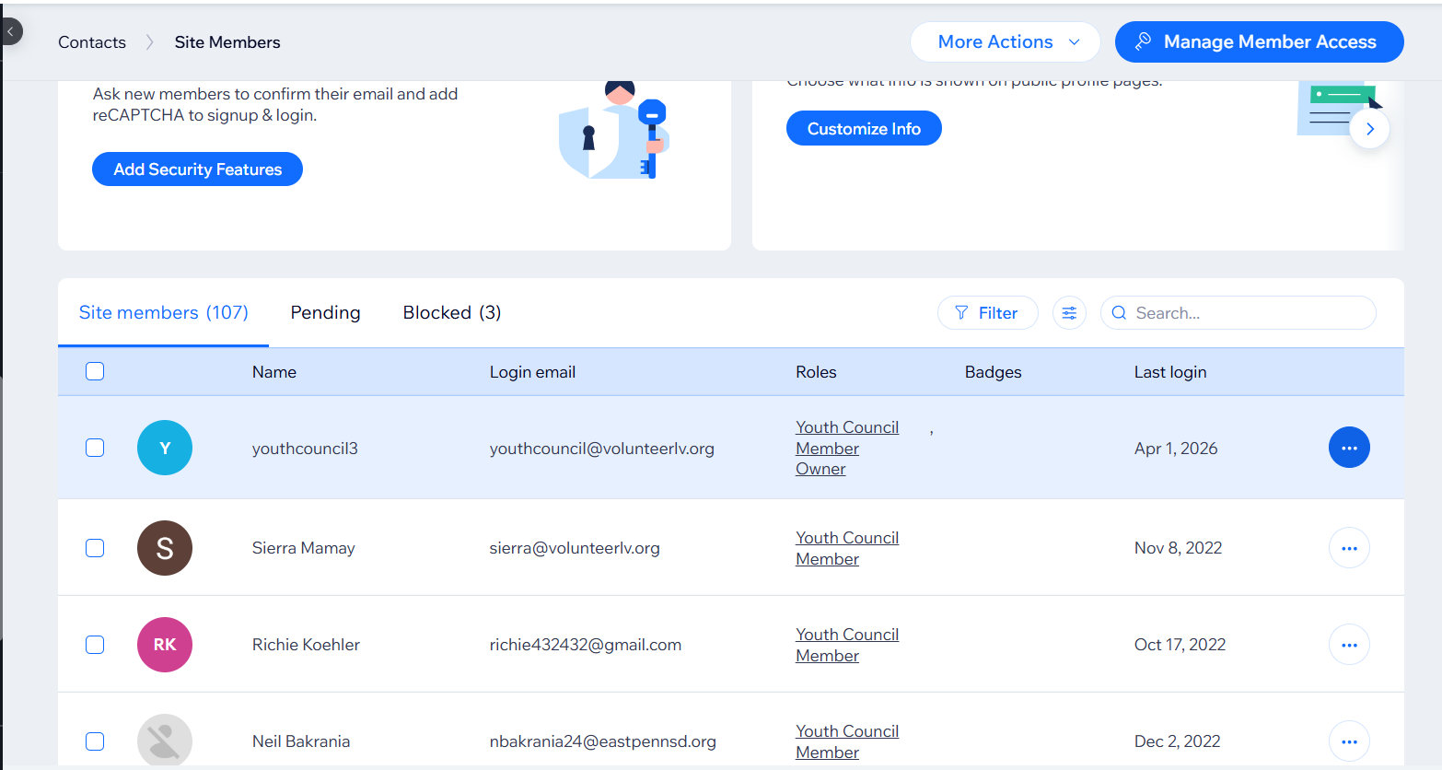
- Click “Manage roles”
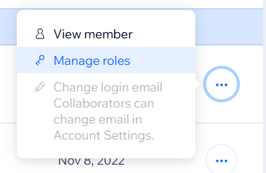
- Select “Youth Council Member” and click the save button.